FLY AWAY project SCreenshot

Table of Contents

1. Src Main WebApp 2

C:\Users\sk\Downloads\flyaway-master\screenshots\servers.png 4

2. HTML Page Display : 4

3. Admin Page: 5

4. Flight Registration Page 5

**5.** **Payment Page** 5

**6.** **Confirm Page** 6

**7.** **Change Password Page** 6

**8.** **Seach Page** 6

9. **Password changed Confirmation** 7

**10.** **My SQL DATABASE** 7

**11.** **List Of Confirmed Flights** 8

**12.** **List Of Flights** 8

# Src Main WebApp

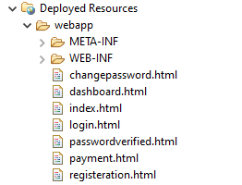

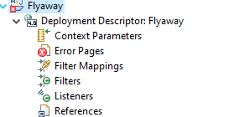

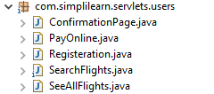

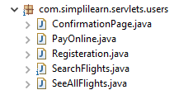

C:\Users\sk\Downloads\flyaway-master\screenshots\com.simplilearn.servlets.util.png

C:\Users\sk\Downloads\flyaway-master\screenshots\com.simplilearn.servlets.sql.png

C:\Users\sk\Downloads\flyaway-master\screenshots\diployment resourses target.png

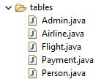

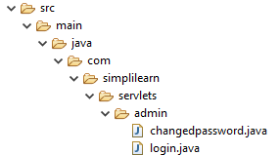

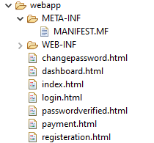

C:\Users\sk\Downloads\flyaway-master\screenshots\src main resourses.png

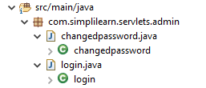

C:\Users\sk\Downloads\flyaway-master\screenshots\sql file setup.png

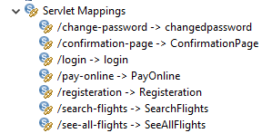

# C:\Users\sk\Downloads\flyaway-master\screenshots\servers.png

# HTML Page Display :

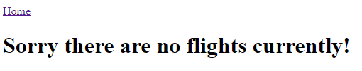

# Admin Page:

# C:\Users\sk\Downloads\flyaway-master\screenshots\out put admin login page.png

# Flight Registration Page

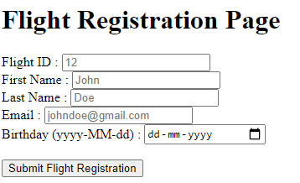

# **Payment Page**

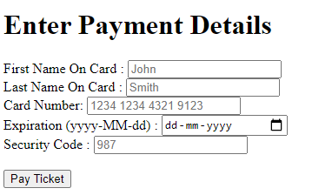

# **Confirm Page**

# C:\Users\sk\Downloads\flyaway-master\screenshots\output confirm flight details.png

# **Change Password Page**

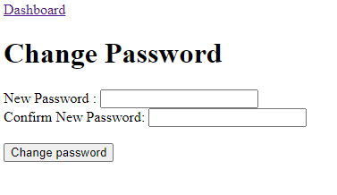

# **Seach Page**

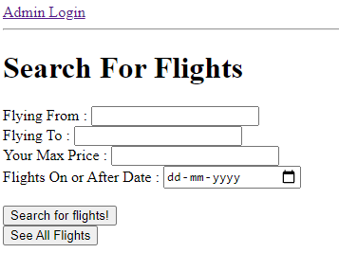

1. **Password changed Confirmation**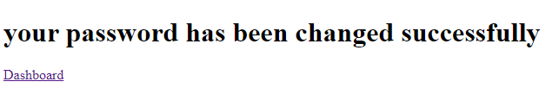

C:\Users\sk\Downloads\flyaway-master\screenshots\JAX-WS Web services.png

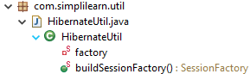

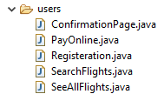

# **My SQL DATABASE**

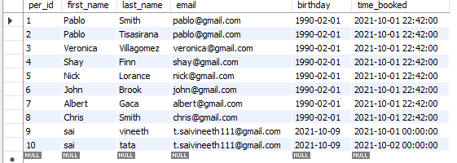

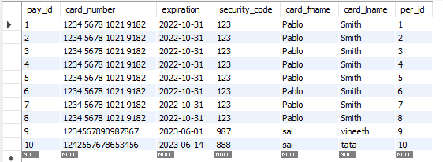

# **List Of Confirmed Flights**

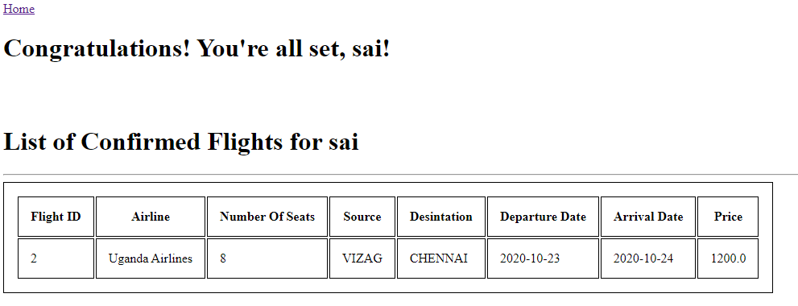

# **List Of Flights**

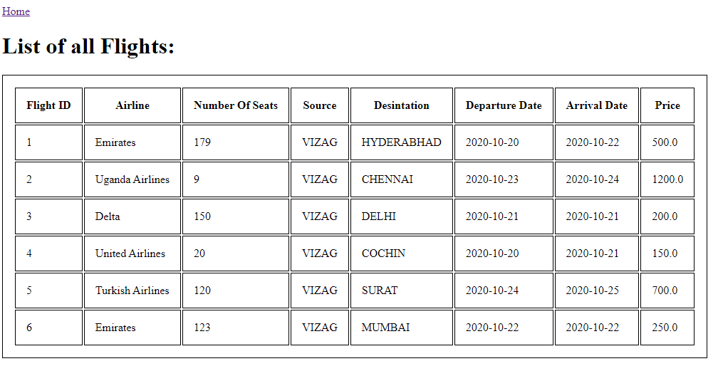

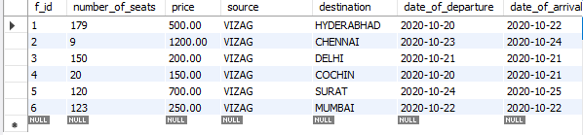

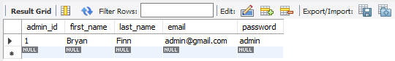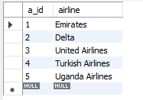

# **--------------------THE END--------------------------**